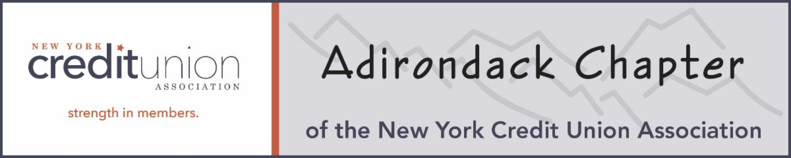
Adirondack Chapter Presents:
A presentation on Fraud Awareness
With Special Agents
Mark Cecilione and Travis Reinheimer
from Homeland Security Investigations
Tuesday, October 7, 2025 @ 5:30pm-8:00pm
@ WestSide 253 New York Rd, Plattsburgh, NY 12903

Open to Management, staff and the Board of Directors of Affiliated Credit Unions
Mark is from the capital district and Travis is from Rouses Point and will be discussing different Fraud Scams that are happening in New York. They will be discussing what things we can do to help prevent our members from being taken advantage of and provide some educational tips.
Where: WestSide 253 New York Road (formally WestSide Ballroom)
When: Tuesday, October 7, 2025
Dinner Selections: Roasted 8 oz Prime Rib of Beef
Chicken Piccata
Maple and Ginger Glazed Salmon

Time: Cash bar from 5:30-6:00pm
Dinner will be served at 6:00pm- Presentation will start during dinner.
Cost: $35.00 per person

Please RSVP attendees and dinner selections to Jody Carpenter, UFirst FCU at jodyc@ufirstfcu.net or (518) 324-0611 by Monday, September 29th.

